TA Dashboard
1. Dashboard Tab
- Add components from Student and Instructor dashboards:
  - Graphs
  - Cards
  - Other common UI components
- Use exactly the same components for consistency.
- Ensure mobile responsiveness.

2. Courses Tab
- Courses tab must show:
  - Labs
  - Sections
  - All related functionality:
    - Create a new lab button must be functional
    - Grade a lab
    - Grade a section quiz
    - Grade attendance
    - Material uploads for lab and section
- Labs and sections are already scheduled by Admin — TA cannot modify scheduling.
- Attendance related to labs and sections should be viewable inside the course tab, not as a separate tab.
- Fix mobile responsiveness.

3. Student Tab
- Display only students assigned to the TA’s courses.
- Remove the ability to add/remove students.
- Ensure the tab is read-only for TA purposes.

4. Attendance Tab
- Remove Attendance tab as a standalone tab.
- Integrate attendance functionality into the Course tab:
  - Lecture attendance
  - Lab/section attendance (as applicable)
- Maintain clarity of attendance records.

5. Office Hours Tab
- Remove Office Hours tab completely.

6. Announcements Tab
- Add Create Announcement form.
- Fix all text colors:
  - Placeholder text
  - Typed text
- Ensure mobile responsiveness and dark mode compatibility.

7. Discussion Tab
- Fix Filters text colors.
- Fix Search text colors.
- Ensure dark mode and mobile responsiveness.

8. Communication Tab
- Remove Communication tab completely.

Student Dashboard – Organized Tasks & Notes
Global Rules
- Fix all low-contrast text colors (placeholders, labels, filters, search fields).
- Ensure dark mode consistency where mentioned.
- Fix mobile responsiveness wherever specified.
- Do not introduce new features beyond what is listed.

1. Global UI (Student)
- Mobile:
  - Fix Avatar and Notification icon placement.
- Global Search:
  - Fix search placeholder text color (bad contrast).
- Chat (Global rule across dashboards):
  - Chat must be full screen.
  - Sidebar stays on the side only.
  - Remove search and extra UI from chat view.
  - Mobile & desktop behavior should match WhatsApp Web.

2. My Class Tab
- Remove all banners.
- Remove all cards.
- Fix Material button functionality.
- Course view (My Class / :id):
  - Fix dark mode colors.
  - Fix mobile responsiveness.

3. Registration Tab
- Fix filters and search text colors.
- When a course is clicked:
  - Show course prerequisites.
  - Show what the student will learn.

4. Community Tab
- Fix post text colors.
- Fix search text colors.
- Fix filter text colors.

5. Schedule Tab
- Add schedule view types:
  - Daily
  - Weekly
  - Monthly
- Fix scroll bar color.
- When a course is clicked in the calendar:
  - Open course materials.

6. Assignments Tab
- Remove Add Assignment button (students cannot create assignments).
- Show only assignments added by TAs.
- When an assignment is clicked:
  - Fix Quick Action button functionality.
  - Fix dark mode colors.
- Fix Completed Assignment action buttons.
- Automatically add assignments to To-Do list.
- Fix mobile responsiveness.

7. Labs Tab
- Adjust lab card layout:
  - Display 2 labs per row.
- Fix mobile responsiveness.

8. Grades & Grade Analysis
- Merge Grades and Grade Analysis into one tab.
- Inside Grade Analysis:
  - Add Set Study Goals button.
- Add export options:
  - Export Grades as PDF
  - Export Grade Analysis as PDF
- Update card icons.
- Fix mobile responsiveness.

9. Attendance Tab
- When a course is clicked:
  - Show attendance details per session.
  - Clearly indicate:
    - Attended days
    - Missed days

10. Analytics Tab
- Remove Analytics tab completely.
- If any feature is important:
  - Move it into Grade Analysis (inside Grades tab).

11. To-Do List Tab
- Update card icons.

12. AI Features
AI Features Tab
- Remove Smart Recommender.
- Keep:
  - OCR Scanner
  - Writing Assistant
AI Notes
- Remove AI Notes tab.
- Add AI Notes button:
  - Appears on each video inside course view
  - Allows generating AI notes from the video content
Smart Study
- Remove Smart Study tab.

13. Files & Notifications
- Remove My Files tab.
Notifications Tab
- Fix Urgent Alerts dark mode colors.

14. Settings Tab
- Make Language setting global (applies to entire platform).

15. Profile & Achievements
Profile Tab
- Fix Download CV text color in light mode.
- Mobile:
  - Profile picture should be aligned to the left.
Achievements Tab
- Fix mobile responsiveness.

Final Output Expectations
- Clear UI behavior per tab
- Explicit mobile responsiveness fixes
- High-contrast, readable text in all modes
- No new features added beyond scope

Instructor Dashboard
1. Dashboard Tab
- Remove all cards.
- Redesign Upcoming Teaching to display:
  - Course name
  - Lecture location
- Remove Quick Actions completely.

2. Courses Tab & Course View
- When a course is clicked, route to:
/courses/:id
- Fix tabs overflow inside the course view.
- Remove the internal course navbar containing:
  - “← Eduverse”
  - Professor avatar
- Fix mobile responsiveness for:
  - Courses tab
  - Course details pages

2.1 Materials (inside course)
- When uploading material, the professor must select which lecture the material belongs to.

2.2 Assignments (inside course)
- Add functionality to Create New Assignment button.
- Make all buttons below each assignment functional.
- Fix Create Assignment modal text colors.

2.3 Grading (inside course)
- Grading tab should display only:
  - Written assignments
  - Uploaded assignments
- Professor or TA must be able to manually grade these submissions.
- MCQ assignments:
  - Auto-graded
  - Show results only.

2.4 Remove Course Tabs
Remove the following tabs from the course view:
- Registration Period
- Settings
- Analytics
- AI Tools

3. Labs & Quiz
3.1 Labs
- Remove Labs tab from Instructor dashboard.
- Labs should exist only for:
  - Admin (add lab to course only)
  - TA (full lab access: details, materials, grading)

3.2 Quiz Tab
- Create New Quiz opens a Google Forms–like builder:
  - Add questions
  - Add answers
  - Select correct answers
- Add AI Quiz Generation button next to Create Quiz:
  - Select materials or lectures
  - Generate quiz
  - Open same editable form before scheduling
- Make all buttons below quizzes functional.
- Add dark mode colors.
- Fix mobile responsiveness.

4. Assignment Tab (Global)
- Fix all text colors in Create Assignment modal.

5. Materials & Roster
- Remove Materials tab (already exists inside course).
Roster Tab
- Show students only.
- Remove toggle state actions.
- Remove Add Student button.
- Add Add Note action per student.
- Merge Grades into the Roster tab.

6. Remove Tabs
Remove the following tabs completely:
- Waitlist
- Search
- Settings

7. Attendance Tab
- Add AI Attendance Tool:
  - Upload image
  - Backend AI processes it
  - Returns Excel file with student IDs
- Fix:
  - Attendance records text color
  - Attendance modal background and text colors

8. Analytics Tab
- Add dark mode color support.
- Ensure all text is readable.

9. Announcements & Communication
- Move all actions from Communication tab into Announcements tab.
- Announcements becomes the only communication hub.
- Remove Communication tab.

10. Discussion & Chat
- Add Discussion tab.
- Chat tab must:
  - Be full screen
  - Support dark mode

11. Profile Tab
- Remove:
  - Badges section
  - Achievements section
Globally :
In Most of Filter and global search The text color issue with contrast
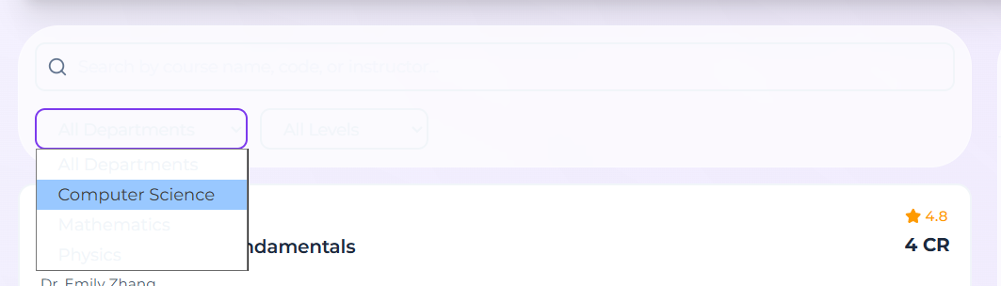
Chat tab => Chat full screen
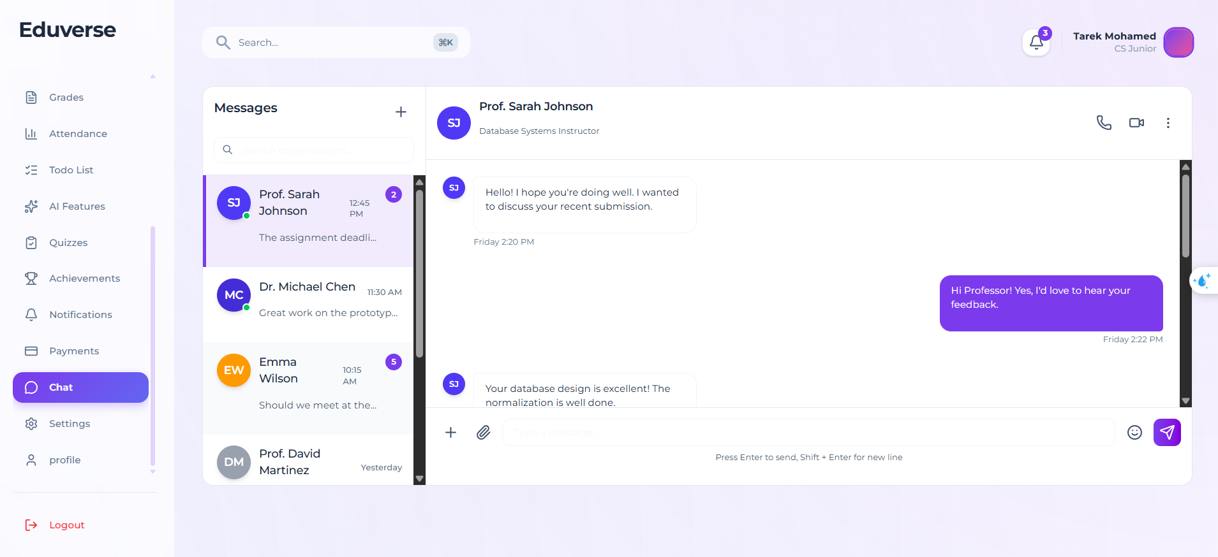

View course darkmode
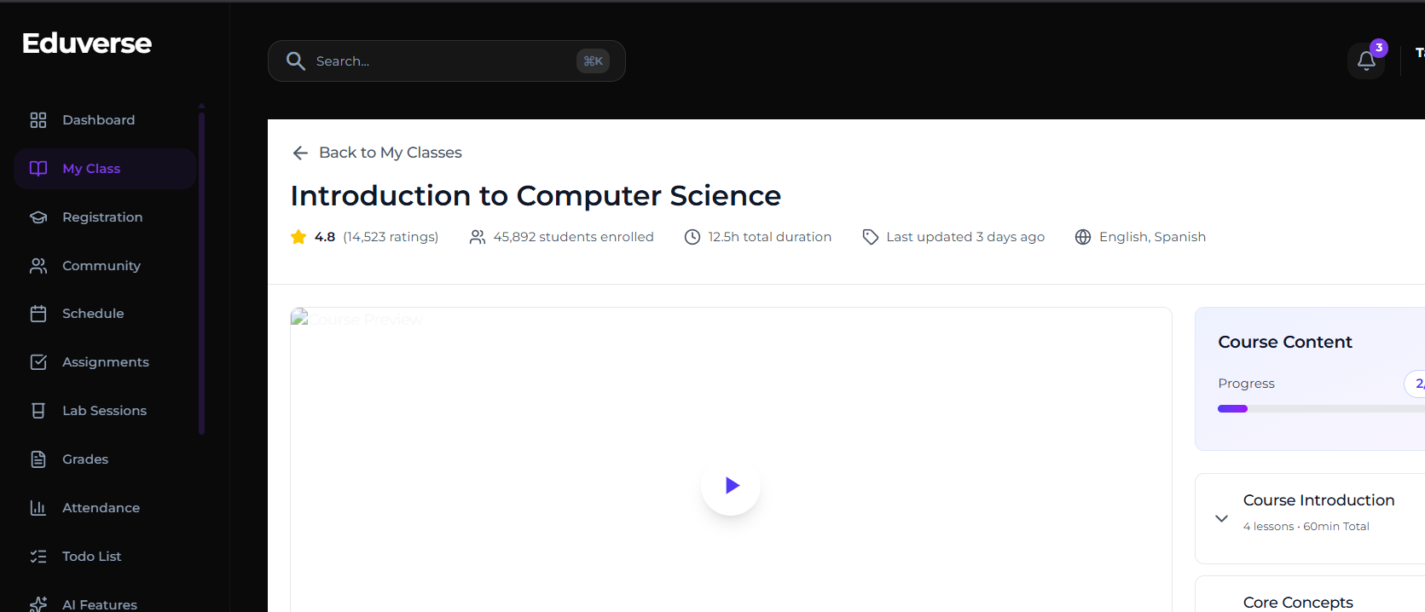

Discussion tab in Instructor isn’t working

TA graphs and cards style is different try to use it from student and instructor
Sign in light mode colors
